ESTIMATION FOR STORAGE REGUIREMENTS

Dim_Promotions

1. **Number of rows per table:**

the number of rows per table = 503.if you plan for 6 times the growth, number of rows will = 503*6 = 3018 rows

2. **Calculate total row size:** # of columns = 8

**a. Determine fixed data size:**

|  |  |  |
| --- | --- | --- |
| Attribute | Date type | Bytes |
| Promo_pk | int | 4 |
| promo_id | int | 4 |
| promo_begin_date | datetime | 8 |
| promo_end_date | datetime | 8 |
| promo_cost | Decimal (8,2) | 5 |
| Total fixed data size |  | 29 |

**b. Determine Variable Data Size**

There are 3 variable-length columns: PROMO_NAME, PROMO_SUBCATEGORY, PROMO_CATEGORY, .

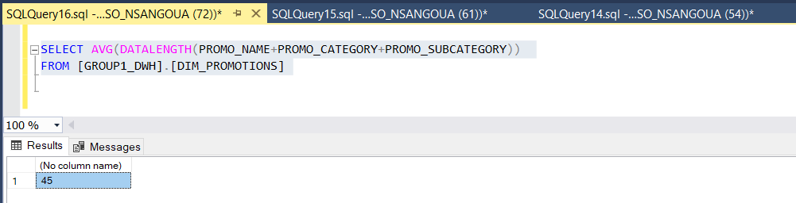

VARIABLE_DATA_SIZE = 2+(3*2) +45= 53

**c. Determine NULL Bitmap**

Size Null Bitmap Size = 2 bytes that store # of columns in null bitmap + Ceiling ((# of columns/8)) = 2 + Ceiling (8/8) = 2 + Ceiling (1) = 3

**d. Determine Total Row Size**

Total Row Size = 4 + 29 +53+3 = 89

3. **Calculate # of rows per page (blocking factor) 1**

ROWS_PER_PAGE = Floor (8096/ (ROW_SIZE + 2 for entry in record offset array)) = Floor (8096/(89+ 2)) = **89 rows per page**

4. Calculate # of page needed for a Heap Table # of pages needed = Ceiling (Rows in Table / # of rows per page) = Ceiling (3018/89) = 34 pages

5. Calculate Heap Size for DIM_PROMOTIONS

Heap size = page size × number of pages = 8192 * 34 = 278528 Bytes

DIM_PRODUCTS

1. Find number of rows per table:

the number of rows per table = 72. If we plan for 2 times its growth, number of rows will =72*2 = 144 rows

2. Calculate total row size: # of columns = 14

a. Determine fixed data size:

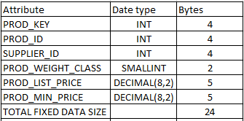

b. Determine Variable Data Size : There are 8 variables size data

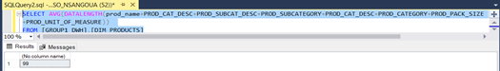

VARIABLE_DATA_SIZE = 2+(8*2) +99= 117

c. Determine NULL Bitmap

Size Null Bitmap Size = 2 bytes that store # of columns in null bitmap + Ceiling ((# of columns/8)) = 2 + Ceiling (14/8) = 2 + Ceiling (1.75) = 2 + 2 = 4

d. Determine Total Row Size

Total Row Size = 4 bytes for row header + FIXED_DATA_SIZE + Null Bitmap + VARIABLE_DATA_SIZE

Total Row Size = 4 + 24+ 117+4 = 149 bytes

3. Calculate # of rows per page (blocking factor) 1

ROWS_PER_PAGE = Floor (8096/ (ROW_SIZE + 2 for entry in record offset array)) = (8096/(149+ 2)) = (53.62) = 54 rows per page

4. Calculate # of pages needed for a Heap Table # of pages needed = Ceiling (Rows in Table / # of rows per page) = Ceiling (144/149) = 0.97 pages

5. Calculate Heap Size Heap size = page size × number of pages = 8192 × 0.97 = 7946.24 Bytes

DIM_CHANNELS

1. Find number of rows per table:

the number of rows per table = 6 if you plan for 2 times the growth, number of rows will = 6*2 = 12 rows

2. Calculate total row size: # of columns = 4

a. Determine fixed data size:

|  |  |  |
| --- | --- | --- |
| Attribute | Date type | Bytes |
| Channel_id | int | 4 |
| Channel_Pk | int | 4 |
| Total fixed data size |  | 8 |

b. Determine Variable Data Size

There are 2 variable-length columns: CHANNEL_DESC, CHANNEL_CLASS 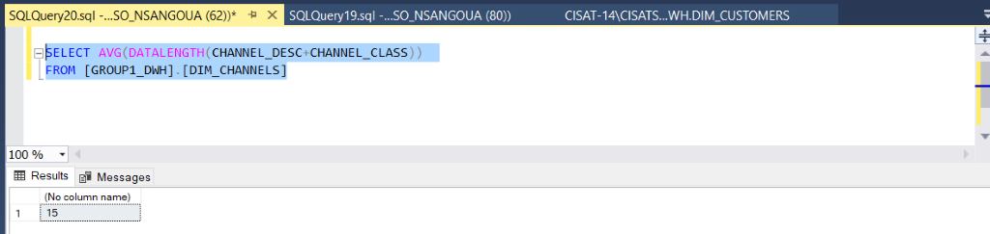 VARIABLE_DATA_SIZE: 2 + (2*2) + 15 = 21

c. Determine NULL Bitmap

Size Null Bitmap Size = 2 bytes that store # of columns in null bitmap + Ceiling ((# of columns/8)) = 2 + Ceiling (4/8) = 2 + Ceiling (0.5) = 2 + 1 = 3

d. Determine Total Row Size

Total Row Size = 4 bytes for row header + FIXED_DATA_SIZE + Null Bitmap + VARIABLE_DATA_SIZE

Total Row Size = 4 + 8 +3+21 = 36 bytes

3. Calculate # of rows per page (blocking factor) 1

ROWS_PER_PAGE = Floor (8096/ (ROW_SIZE + 2 for entry in record offset array)) = Floor (8096/(36+ 2)) = Floor (213.05) = 213 rows per page

4. Calculate # of pages needed for a Heap Table # of pages needed = Ceiling (Rows in Table / # of rows per page) = Ceiling (12/213) = 0.06page

5. Calculate Heap Size Heap size = page size × number of pages = 8192 × 0.06= 528 Bytes

DIM_CUSTOMERS

1. The number of rows = DIM_CUSTOMERS. if you plan for 2 times the growth, number of rows will = 55500 = 111000 rows

2. Calculate total row size: # of columns = 30

a. Determine fixed data size:

|  |  |  |
| --- | --- | --- |
| Attribute | Date type | Bytes |
| cust_key | int | 4 |
| cust_id | int | 4 |
| cust_postal_code | int | 4 |
| cust_year_of_birth | smallint | 2 |
| cust_education | int | 4 |
| cust_no-of-children | int | 4 |
| cust_checking_bal | int | 4 |
| cust_race | int | 4 |
| cust_income | float | 4 |
| cust_assets | int | 4 |
| cust_houses | int | 4 |
| cust_stocks | int | 4 |
| cust_bonds | int | 4 |
| cust-home_equity | int | 4 |
| cust_networth | int | 4 |
| cust_version | smallint | 2 |
| cust_date_from | datetime | 8 |
| cust_date_through | datetime | 8 |
| Total fixed data size |  | 76 |

b. Determine Variable Data Size

There are 11 variable-length columns:

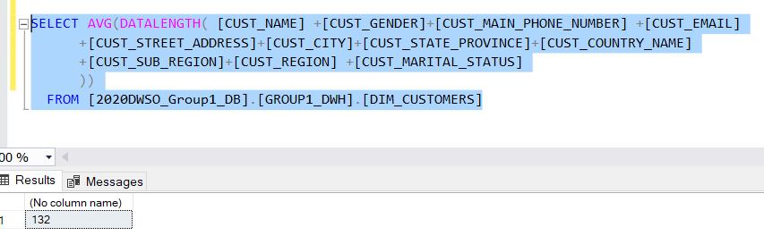

VARIABLE_DATA_SIZE: 2 + (11*2) + 132 = 156

c. Determine NULL Bitmap

Size Null Bitmap Size = 2 bytes that store # of columns in null bitmap + Ceiling ((# of columns/8)) = 2 + Ceiling (30/8) = 2 + Ceiling (3.75) = 2 + 4 = 6

d. Determine Total Row Size

Total Row Size = 4 bytes for row header + FIXED_DATA_SIZE + Null Bitmap + VARIABLE_DATA_SIZE

Total Row Size = 4 + 76+6+156 = 242 bytes

3. Calculate # of rows per page (blocking factor) 1

ROWS_PER_PAGE = Floor (8096/ (ROW_SIZE + 2 for entry in record offset array)) = Floor (8096/(242+ 2)) = Floor (33.18) = 33 rows per page

4. Calculate # of pages needed for a Heap Table # of pages needed = Ceiling (Rows in Table / # of rows per page) = Ceiling (111000/33) = 3364 pages ceiling

5. Calculate Heap Size = page size × number of pages = 8192 × 3364= 27557888 Bytes

DIM_DATE

1. Find number of rows per table:

the number of rows per table = 7350. If we plan for 2 times its growth, number of rows will = 7350*2 = 14700 rows

2. Calculate total row size: # of columns = 26

a. Determine fixed data size: 104

b. Determine Variable Data Size : There is not variable data size

c. Determine NULL Bitmap

Size Null Bitmap Size = 2 bytes that store # of columns in null bitmap + Ceiling ((# of columns/8)) = 2 + Ceiling (26/8) = 2 + Ceiling (3.25) = 2 + 4= 6

d. Determine Total Row Size

Total Row Size = 4 bytes for row header + FIXED_DATA_SIZE + Null Bitmap + VARIABLE_DATA_SIZE

Total Row Size = 4 + 104+ 6 = 114 bytes

3. Calculate # of rows per page (blocking factor) 1

ROWS_PER_PAGE = Floor (8096/ (ROW_SIZE + 2 for entry in record offset array)) = (8096/(114+ 2)) = (69.79) = 70rows per page

4. Calculate # of pages needed for a Heap Table # of pages needed = Ceiling (Rows in Table / # of rows per page) = Ceiling (14700/70) = 210 pages

5. Calculate Heap Size = page size × number of pages = 8192 × 210 = 1720320 Bytes

DIM_AGENTS

1. Find number of rows per table:

the number of rows per table = 524. If we plan for 2 times its growth, number of rows will = 524*2 = 1048 rows

2. Calculate total row size: # of columns = 4

a. Determine fixed data size: AGENT_KEY + AGENT_ID = 4+4 = 8

b. Determine Variable Data Size :

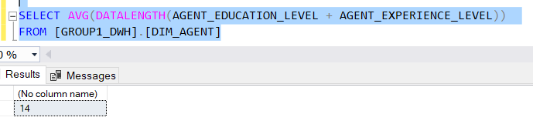

There are 2 variables = 2+ (2*2) +14 = 20

c. Determine NULL Bitmap

Size Null Bitmap Size = 2 bytes that store # of columns in null bitmap + Ceiling ((# of columns/8)) = 2 + Ceiling (4/8) = 2 + Ceiling (0.5) = 2 + 1= 3

d. Determine Total Row Size

Total Row Size = 4 bytes for row header + FIXED_DATA_SIZE + Null Bitmap + VARIABLE_DATA_SIZE

Total Row Size = 4 + 8+ 20 = 32 bytes

3. Calculate # of rows per page (blocking factor) 1

ROWS_PER_PAGE = Floor (8096/ (ROW_SIZE + 2 for entry in record offset array)) = (8096/(32+ 2)) = (238.117) = 238 rows per page

4. Calculate # of pages needed for a Heap Table # of pages needed = Ceiling (Rows in Table / # of rows per page) = Ceiling (1048/238) = 4.40 OR 5 pages ceiling

5. Calculate Heap Size = page size × number of pages = 8192 × 5 = 40960 Bytes

CUSTOMER_PAYMENT_SUMMARY is estimated at 1820320 bytes

CUSTOMER_SALES_SUMMARY is estimated 153042 bytes

FACT_ORDERS:

1. Find number of rows per table:

the number of rows per table = 504564. If we plan for 2 times its growth, number of rows will = 504564*2 = 1081128 rows

2. Calculate total row size: # of columns = 11

a. Determine fixed data size:

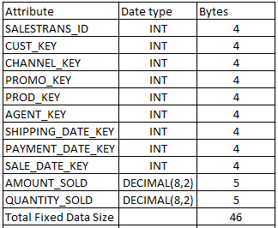

b. Determine Variable Data Size: There is not variable data size

c. Determine NULL Bitmap

Size Null Bitmap Size = 2 bytes that store # of columns in null bitmap + Ceiling ((# of columns/8)) = 2 + Ceiling (11/8) = 2 + Ceiling (1.375) = 2 + 2 = 4

d. Determine Total Row Size

Total Row Size = 4 bytes for row header + FIXED_DATA_SIZE + Null Bitmap + VARIABLE_DATA_SIZE

Total Row Size = 4 + 46 + 4 = 54 bytes

3. Calculate # of rows per page (blocking factor) 1

ROWS_PER_PAGE = Floor (8096/ (ROW_SIZE + 2 for entry in record offset array)) = (8096/(54+ 2)) = (144.5714) = 145 rows per page

4. Calculate # of pages needed for a Heap Table # of pages needed = Ceiling (Rows in Table / # of rows per page) = Ceiling (1081128/145) = 7456 pages

5. Calculate Heap Size = page size × number of pages = 8192 × 7456 = 61079552 Bytes